Response to Intervention (RTI) in the Alberta Context
Team Action Plan
SECTION A
- How will an increased understanding of and commitment to RTI  add value to our efforts as a school/jurisdiction?  SHARED VISION | Essential Conditions for Implementation
- How could the adoption and/or framework of an RTI approach connect with other initiatives, priorities and practices in our school/jurisdiction? | Essential Conditions for Implementation

- What are our strengths and resources (e.g., leadership expertise, collaborative planning time, professional learning activities, materials, infrastructure, human resources) does our school/jurisdiction have that support a RTI approach?  RESOURCES | - What barriers and challenges might impact the implementation of a RTI approach in our school/jurisdiction? | Essential Conditions for Implementation
 | - Policies | Essential Conditions for Implementation
 | - Practices | Essential Conditions for Implementation
 | - Attitudes | Essential Conditions for Implementation
 | - Capacity | Essential Conditions for Implementation
 | - Resources | Essential Conditions for Implementation

- Who should be the key partners putting RTI into practice in our school/jurisdiction?  LEADERSHIP | Essential Conditions for Implementation
- What collaborative approaches and practices support the implementation of an RTI approach in our school/jurisdiction?  COMMUNITY ENGAGEMENT | Essential Conditions for Implementation
SECTION B
- What capacity-building activities could support putting RTI into practice in our school/jurisdiction?  TEACHER PROFESSIONAL GROWTH | Essential Conditions for Implementation
- How can we integrate technology in our school/jurisdiction to support an RTI approach?  RESOURCES | Essential Conditions for Implementation

- How would students, teachers and other education partners benefit from an RTI approach?  What are the possible outcomes as a result of RTI? | - What evidence could we collect to show that an RTI approach would make a difference to student success? (e.g. pre-post test measures) | Essential Conditions for Implementation
RESEARCH AND EVIDENCE |  | Essential Conditions for Implementation

First Steps in Planning

SECTION C
- How will we measure success?  RESEARCH AND EVIDENCE |  | Essential Conditions for Implementation
- What will our key messages be to support RTI? (How will we promote the RTI approach in our school/jurisdiction?) | - How will we communicate about RTI with: | Essential Conditions for Implementation
 | - School leaders | Essential Conditions for Implementation
 | - School staff | Essential Conditions for Implementation
 | - Parents | Essential Conditions for Implementation
 | - Students | Essential Conditions for Implementation
 | - Other community/educational partners | Essential Conditions for Implementation
SHARED VISION |  | Essential Conditions for Implementation

- How will we build capacity (including planning for teacher professional growth)?  TEACHER PROFESSIONAL GROWTH | Essential Conditions for Implementation
- How will we collaborate beyond a school/jurisdiction?  COMMUNITY ENGAGEMENT | Essential Conditions for Implementation
- Who will champion RTI in our school/jurisdiction?  LEADERSHIP | Essential Conditions for Implementation
Essential Conditions Self-Assessment: RTI and success for all students
Date: _________________________
ESSENTIAL CONDITION | DESCRIPTION | NOT YET | PARTLY | YES | EVIDENCE FOR OUR SELF-ASSESSMENT / GOAL FOR FURTHER WORK
Shared Vision | Education partners share an understanding of and commitment to a RTI approach for student success
Leadership | Leaders at all levels have the capacity to champion the shift from the current reality to a RTI approach and a commitment to the success of all students.
Research and Evidence | Current research, evidence and lessons learned inform decisions to implement a RTI approach.
Resources | Human resources, materials, funding, and infrastructure are in place to support an RTI approach.
Teacher Professional Growth/Capacity Building | Teacher (all staff) knowledge, skills and attributes are enhanced through ongoing professional learning.
Time | Time is provided to support the implementation of an RTI approach.
Community Engagement | Parents, school councils, students, community members and post-secondary institutions are partners in supporting an RTI approach for student success
Adapted from: A Guide to Support Implementation: Essential Conditions http://www.essentialconditions.ca/
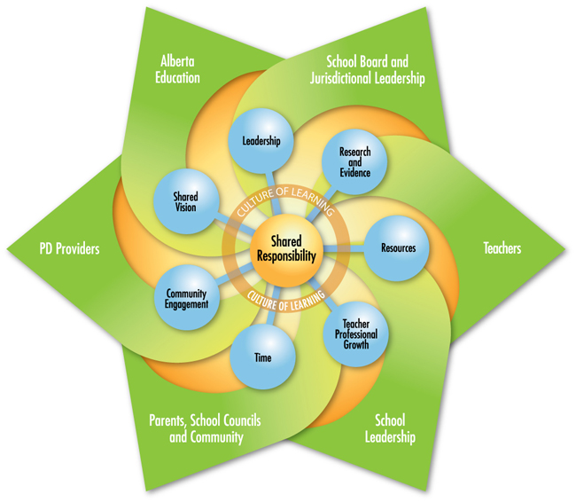
A Guide to Support Implementation:
Essential Conditions
www.essentialconditions.ca

Successful implementation is possible in environments where education stakeholders are committed to sharing the responsibility for supporting implementation within a culture of learning.

Addressing the seven essential conditions (blue dots) will support implementation fidelity.

